

Search about

**Jarir Bookstore**

|  |  |  |
| --- | --- | --- |
| Student Number | Student Name | N |
| 00000000 | سعد عبد الله إبراهيم السهلي | 1 |
| 00000000 | محمد معجب محمد الدوسري | 2 |
| 00000000 | ريان محمد عبيد الشريف | 3 |
| 00000000 | ناصر حمد ناصر ال ذيبان | 4 |

**د.محمد سعد محمد العسيري Supervised by :**

**Year: 2023**

*INDEX*

|  |  |
| --- | --- |
| **Page** | **Content** |
| **3** | Introduction |
| **4** | Strategy |
| **5** | Usability |
| **8** | Content and Readability |
| **9** | -Conclusion  - Recommendations |

**1. Introduction**

**1.Define the purpose of the website**

*E-Commerce, for example (see image 1)*

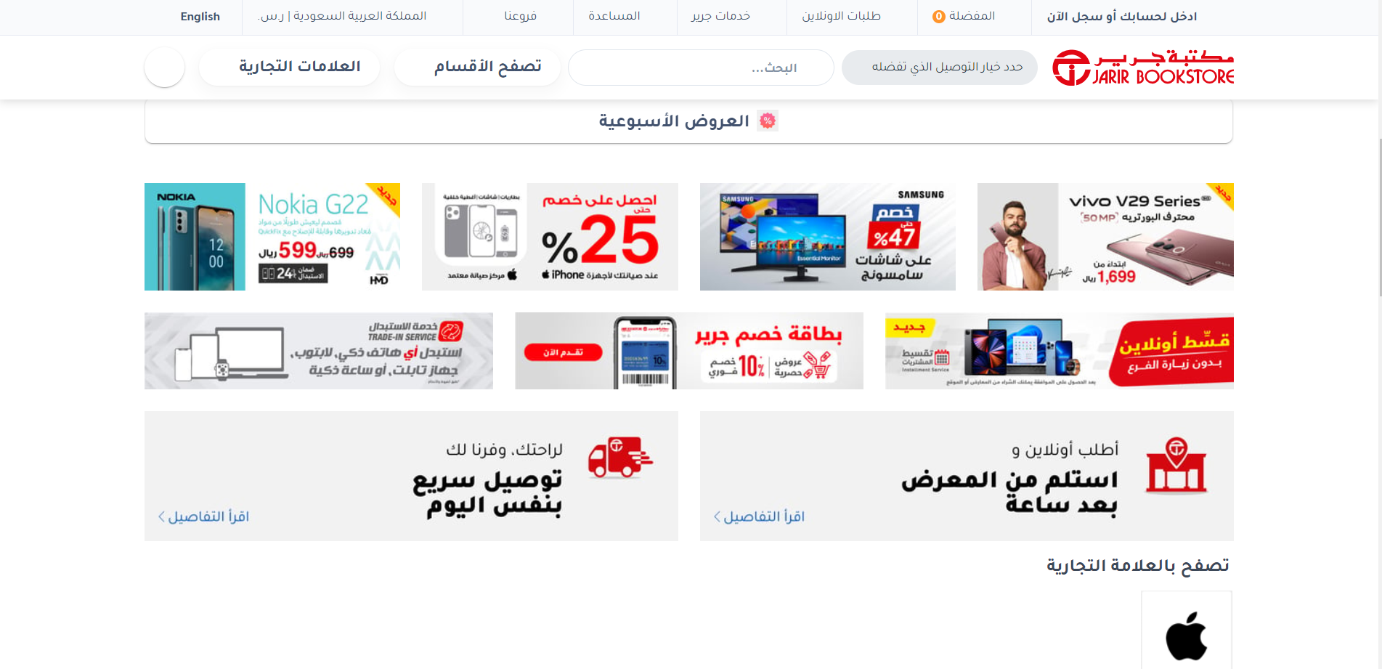

*(Image 1)*

**2.Explain its services**

*Its services like: Installment Service, Trade-in-Service and Jarir Tickets (See image 2).*

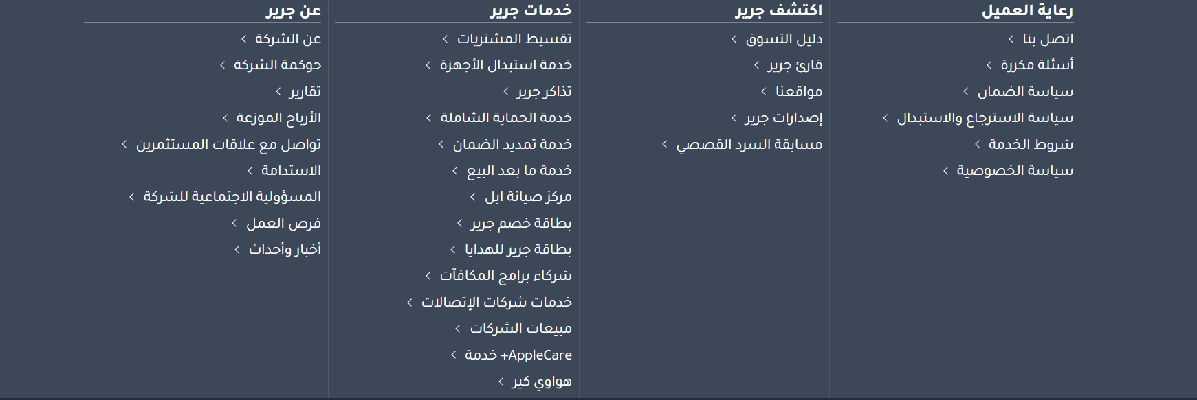

*(Image 2)*

**3.What is the domain address?**

[*www.jarir.com*](http://www.jarir.com)

**2.Strategy**

1. **What is the category of the business, and is this obvious on the website?**

*Yes, it is clear, for example the attached picture (See* *image 3).*

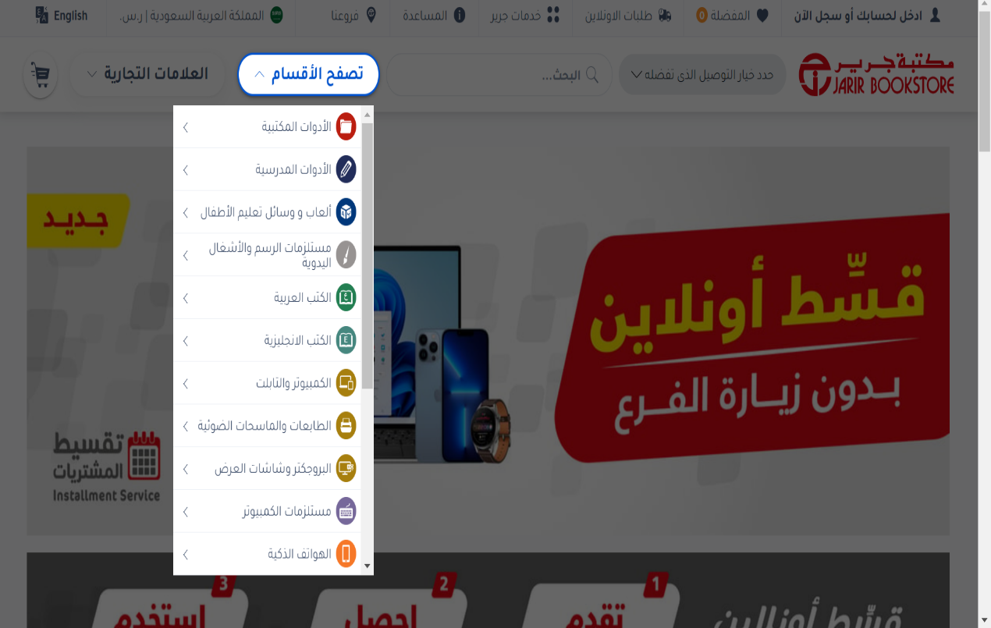

*(Image 3)*

1. **Is the design accomplishing the purpose of the website?**

*Yes, the design is clear to the customer that it is an online store, for example the attached picture**. (See image number 1, page 3)*

1. **Who is the target audience and how does the design take this into consideration?**

*The site targets people in general. Yes, the site helps the public get an idea about the site. For example, the previously attached picture (See image number 3, page 4)*

**3.Usability**

**1.** **How long does it take for pages to load, and will the visitors get bored waiting?**

*No, the time it takes for pages to load is fast and It does not make visitors bored and Look at the website speed test image to see the results (See image 4)*

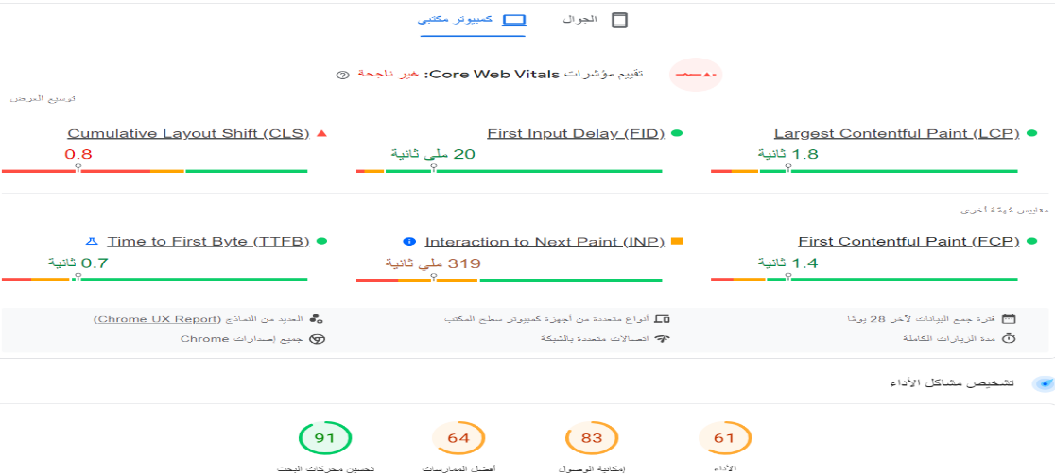

*(Image 4)*

**2.Can information be found easily?**

*Yes, you can access the site information easily, for example the attached picture (See image number 2, page 3)*

**3. Is there a search button available for visitors?**

Yes, there is a button for me to search for visitors and it is located at the top of the page (See image 5).*.*

*(Image 5)*

**4.Are all the links working? There are tools available online to check a website's links.**

No, not all links work. There are 27 links that do not work out of 2000 links. *(See image 6).*

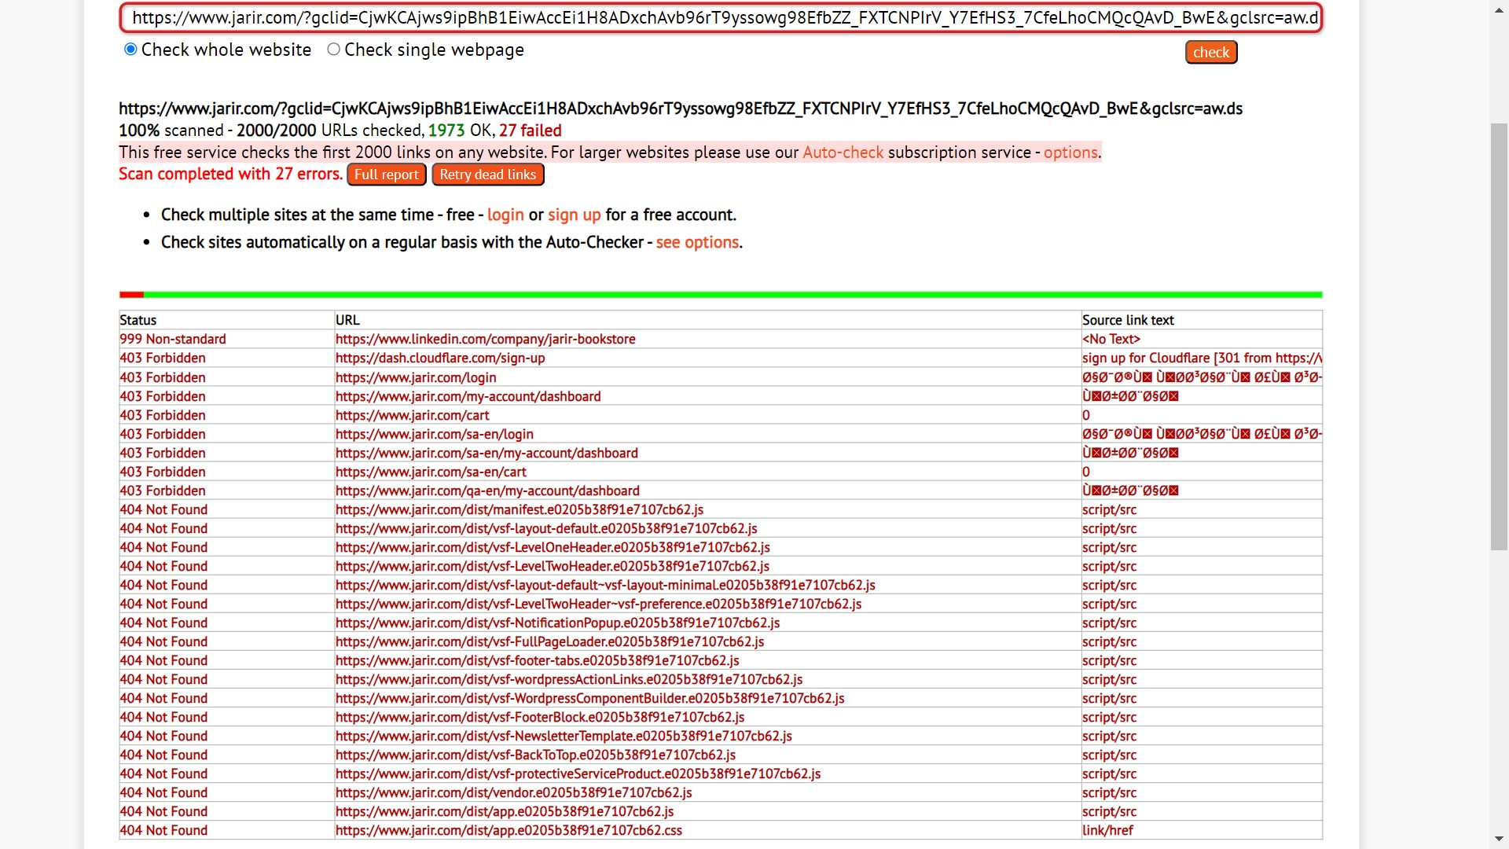

*(Image 6)*

**5. Does the website work in different browsers? Check all the widely used browsers.**

Yes, it works in several browsers, such as

Google Chrome Microsoft Edge Firefox

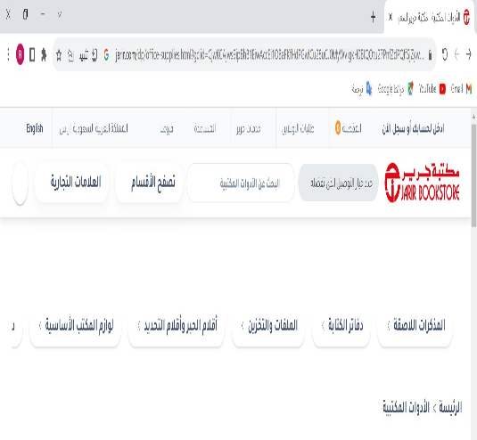

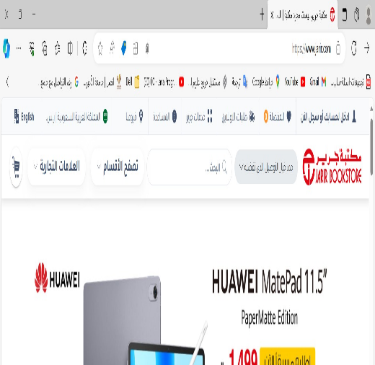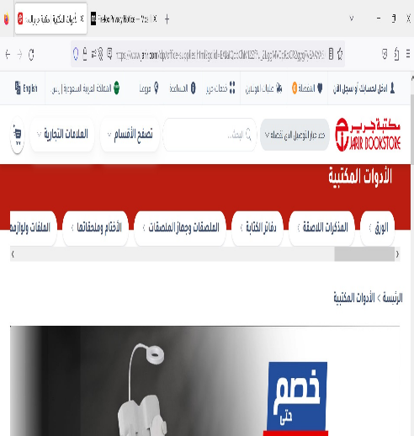

**6. Does the website work on mobile devices?**

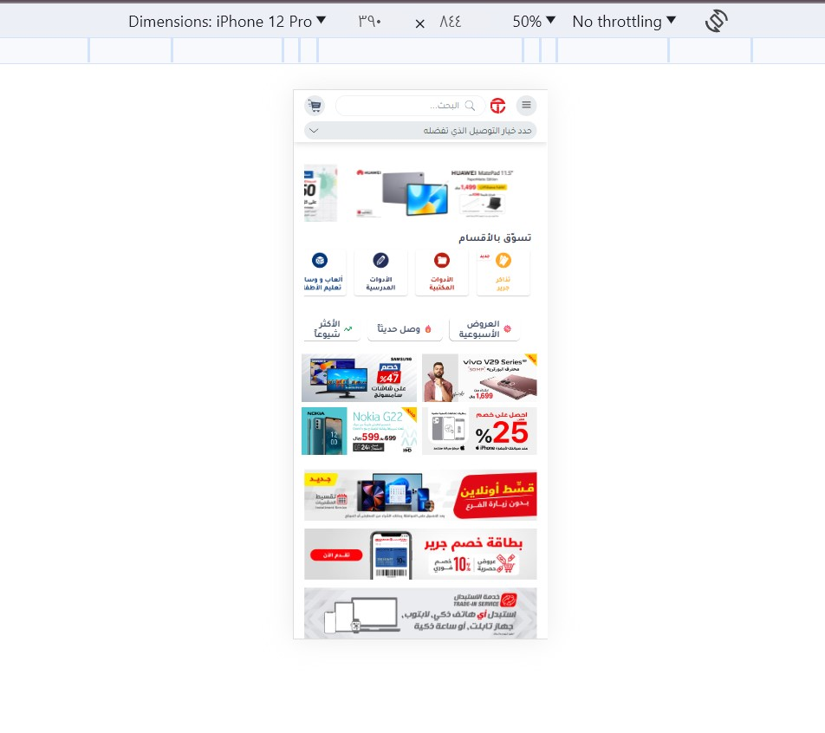Yes, it works on mobile devices, for example the iPhone 12 Pro *(See image 7).*

*(Image 7)*

**4.Content and Readability**

**1.Are the fonts that have been chosen easy to read?**

Yes, the font is very clear and readable (See image number 1, page 3).

**2.Is there considerable contrast between the font color in the background color?**

Yes, there is a difference between font color and background color (See image number 1, page 3).

**3.Is the text an appropriate size?**

The font size is very appropriate and consistent (See image number 1, page 3).

**4.Is the content concise yet still useful?**

Yes, short, concise and useful (See image number 1, page 3).

**Conclusion**

At the end of this report, we talked about the Jarir website and the services it provides in terms of electronic commerce, especially the sale of office products and digital devices. We also touched on the shape and design of the website, the target group for the website, and the types of search engines that the website and mobile phones operate on as well. Finally, we talked about the type and the color of the fonts used on this site.

**Recommendations**

1-Providing 24-hour customer service

2-Providing languages other than Arabic and English

3-Provide lighting at night in order to reduce the brightness of the page and also provide eye comfort.

4-Providing delivery of products to several countries